Computer Programming 12

Please read each portion of the following pages carefully. It must be completed in full before you are placed in the active class. It’s worth 100 marks and makes up 5% of your overall grade. Please answer right on this form.
Course Selection/Student Learning Plan (SLP) Form
Answer the following questions and fill in the chart below. Don’t forget to date and sign the page.
- Why have you selected this course and how does it fit into your Educational Goals?
As I learned more and more about programming, I started to get more and more interested in it. Now I find I can do many complicated programming tasks and look forward to learning more skills in this new course. I am also planning to apply into engineering so having vital skills in programming would be useful in the future.
- What grade are you currently in?
Currently in Grade 11
In the following chart fill in any grade 10, 11 and 12 courses you have already completed = C or are currently taking/are in progress = IP. If there are courses you have not taken yet simply leave it blank.
Required Courses…

GRADE 10 | C/IP | GRADE 11 | C/IP | GRADE 12 | C/IP
English 10 (two 2-credit courses) | C | Any English 11 course | IP | Any English 12 course
Any Mathematics 10 credit |  | Explorations in Social Studies 11 |  | Career Life Connections 12
Physical and Health Education 10 | C | Any Science 11 course | IP
Career Life Education 10 |  | Any Mathematics 11course | C
Social Studies 10
Science 10 | C
List ONE Fine Arts/Applied Skills course from grade 10, 11 or 12: |  |  |  | Creative Arts | C
Elective Credits…
GRADE 10 | C/IP | GRADE 11 | C/IP | GRADE 12  (Minimum 3 courses) | C/IP
Psychology | C | Creative Arts | C
Business/Economics | C | Philosophy | C
History | C | Chemistry | IP
 |  | Biology | C
 |  | Japanese | IP
 |  | Computer Programming | C
You can add more rows by clicking into the last box (bottom right) and clicking on the Tab key.
Student’s/Parent’s E-Signature: Ho Leung Chan Date: 26/1/2023
Student’s Full Name (Please Print): Anson Chan Email: ananryry180@gmail.com
Date of Birth (Month,-Day,-Year): 05/09/06 PEN (MUST be 9-digits): 146701776
NOTE: For the E-Signature you can simply type in the name.
Course Information:

Please read the following information with regards to your course.
https://curriculum.gov.bc.ca/curriculum/adst/12/computer-programming

Prescribed Learning Outcomes
Please review the Ministry of Education’s Prescribed Learning Outcomes for Computer Programming 12:

Resources
All the resources are available online.

Assessment
The Computer Programming 12 course is graded as follows:
- 70% - Assignments and Online Quizzes
- 30% - Capstone Project

Course Timeline

The following timeline will be used in this course.

Course Topics/Units | Approximate Date I Intend to complete.
Start Date (The Day You Enrolled) | Jan 26
- Module 1 Different Types of Data | Feb 3
- Module 2 Data Structures | Feb 17
- Module 3 Algorithms | March 3
- Module 4 Data Persistence | March 17
- Module 5 GUI’s | March 31
- Module 6 Cap Stone Project | April14

The Assignment

Email and Image Profile

- Add an image that represents you to your profile. If you enjoy sports then add a sports image. Go to My Home > Profile > Change Picture
- Add a signature (your name) to your VLN Email. Go to Email tab > Settings.
- Forward your incoming VLN email to your external email address. Go to Email tab > Settings (Forwarding Options).

Questions

- Take a screen shot of a “Hello World” program in Intelij using Java.
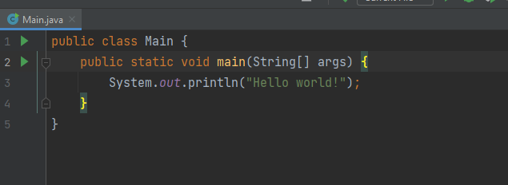
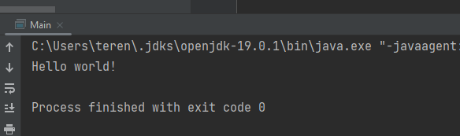

- What are different behaviours between reference data and primitive data? Use an example.
Primitive variable:
- Store values
- Cannot be null
- When assigning variables, the values are copied
- For comparison (==), the values are compared
Reference variable:
- Store the “memory location” of the data
- Can be null
- When assigning variables, the “references addresses” are copied instead.
- For comparison (==), the “reference addresses” are compared

For example, I created a class as follows:
public class Person{
String name;
Person(String input){this.name = input;}
}
For the following code
// For reference variable
Person A = new Person("Ann");
Person B = new Person("Ben");
B = A;
System.out.println(B.name); // B's name is Anne
A.name = "Dale"; // Change A's value
System.out.println(B.name); // B's name changed to Dale now
// For primitive variable
int a = 10;
int b = 20;
b = a;
System.out.println(b); // b's value is 10
a = 30; // Change a's value
System.out.println(b); // b's value unchanged
The output is
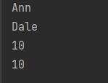

- Write a simple program in Java that can do the following: (Screen Shot of code will suffice)
Ask the user how many hot dogs they want to buy.
Ask the user how many drinks they want to buy.
Print out the total they owe including taxes (12%) $3.50 for hotdogs and $1.00 for drinks.
public static void main(String[] args) {
Scanner scanner = new Scanner(System.in);
System.out.println("How many hotdogs do you want?");
int hotdogs = scanner.nextInt();
System.out.println("How many drinks do you want?");
int drinks = scanner.nextInt();
double total = (hotdogs*3.5 + drinks)*1.12;
total = Math.round(total * 100.0) / 100.0;
System.out.println("Total you owe $" + total);
}

Outcome is
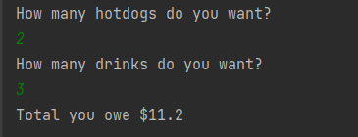

- Write code that makes an array that holds integers. Fill it with random numbers then reverse the order of the array using a for loop. (Screen shot)
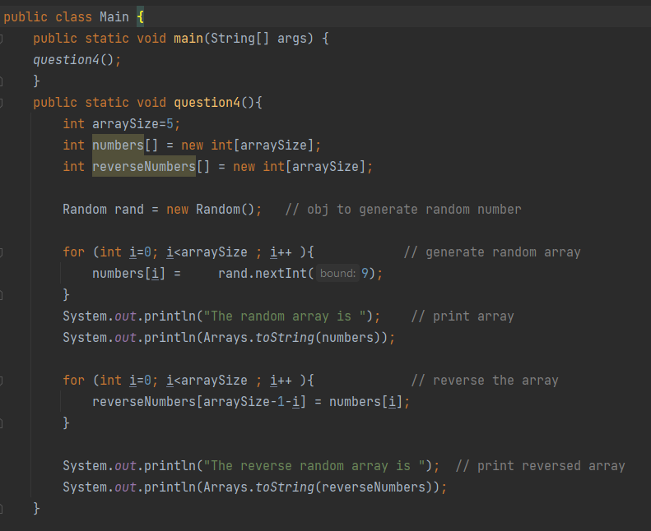
Outcome is:
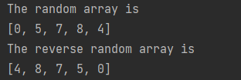

- Create the following Data Type: (Screen Shot)
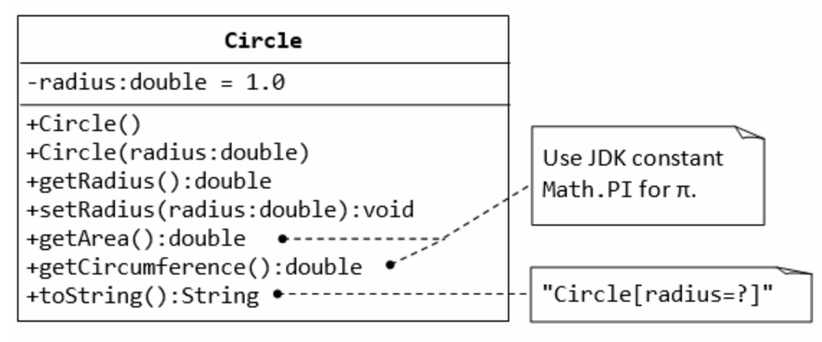
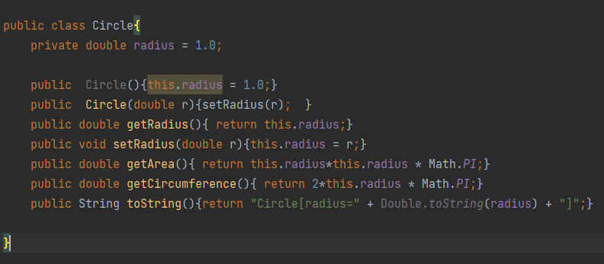

- What would be the output of the following:
String name = “John Carmack”;
System.out.println(name.substring(6));
Answer
“armack” will be printed out

- What would be the output of the following:
int x = 20;
int y = 15;
boolean z = false;
System.out.println(!z || x < y);
Answer
The Boolean value true will be printed out.

- Create a github repository for this course called YourNameProgramming12 (Link)
Link
https://github.com/ansonc314/AnsonC-Programming/tree/main/Anson%20Programming12

- Write a program that can determine what quandrant a coordinate falls. (github link)
Use scanner to read 2 lines of code from keyboard inputs, the first line is the x-coordinate and the second line is the y-coordinate
determine which quadrant it falls in by printing out “Quadrant #”
Link
https://github.com/ansonc314/AnsonC-Programming/tree/main/Anson%20Programming12/startup/question9

- Write a program that can solve the following program: (Github Link)
Scanner takes in a text file called “happyorsad.txt”
Reads 1 line of text
Detects if there is a happy emoticon :-) or a sad emoticon :-(
Outputs the following:
None detected print none
equal amount print unsure
more happy than sad print happy
more sad than happy print sad
Link
https://github.com/ansonc314/AnsonC-Programming/tree/main/Anson%20Programming12/startup/question10

- What programming experience if any do you have?
Answer
Learn Java in the programming 11 course. Also, Scratch as well when young

- Why does learning about programming interest you?
Answer
Learning programming is interesting. It is like building Lego. As I learned more, I found that I can do a lot of things using computer. In the last course, I learned to create a program for storing passwords. The experience was great knowing I can create something useful for my own use.

- Do you intend to pursue a career in computer science?
Answer
It is one of my choices, other than engineering (which also requires programming skills)

- What topics about computer science interest you the most?
Answer
Artificial Intelligence, e.g., how computer can learn to solve a problem itself
- A logic Puzzle
A company employee generates a series of five-digit product codes in accordance with the following rules:
The codes use the digits 0, 1, 2, 3, and 4, and no others.
Each digit occurs exactly once in any code.
The second digit has a value exactly twice that of the first digit.
The value of the third digit is less than the value of the fifth digit.
If the last digit of an acceptable product code is 1, it must be true that the
(A) first digit is 2
(B) second digit is 0
(C) third digit is 3
(D) fourth digit is 4
(E) fourth digit is 0

Answer (A) first digit must be 2. The product code is 24031

Anti-Plagiarism Student Contract

Top of Form
I, Anson Chan, understand that VLN has a zero tolerance policy on plagiarism. Plagiarism is presenting someone else’s work (or parts of someone else’s work) as though it is my own. I understand that if I am found to be plagiarizing, I will receive a zero for that assignment. Repeated offenses will result in failure or withdrawal from the course or school.

Top of Form

Formal procedures for cases of plagiarism:
First incident: Student receives zero on assignment and must contact teacher by email immediately.

Second incident: Student receives zero on assignment and must make an appointment to see the teacher in person.

Third incident: Student fails or is withdrawn from course and/or school.

Assignment Feedback

Course Name: Computer Programming 12
Student Name: Anson Chan
Mark: %

Teacher Comments:

Ok, I am done the assignment, what do I do now?
- First step is to SAVE AS and name the file StartUp_LastnameFirstname_CP12.doc
- Next step is to upload to the ASSIGNMENTS in your classroom.
- The teacher will then mark your assignment, provide you with feedback and then begin the process open the whole course to you.

